BUSINESS ANALYSTS NOTES

YouTube Channels
Priority
- Techcanvass
- Karaleise
- The BA Tutor
- Bridging the Gap
- The Agile Business Analyst
Optional
- Angelo the BA
- The Career Force
- BA Blocks
- Learn with Lukas
- Lucidchart DFD tutorial
- Esta Lessing / Business Analysis Excellence
- IIBA (BABOK)

VIDEO: WHAT IS BRD
- BRD: just means in layman terms that it is a document that consists of the requirements from a business. it talks about what the application is capable of executing but not consisting of the elements like buttons, fields, etc. so in short it is a documentation of what the system must have
- the businesses arises because either of the two: the need or an opportunity

Compliance or Governance Perspective:
- first area is document revision there are columns for date, version number, document changes.
- second section is approvals/ stakeholders. well I think here that there are specific people who will decide weather a feature is approved or for revisions and I also think that it is related to RACI matrix?

Project Perspective:
- third section is the introduction that consists of project summary, objectives, background. so in this part just like writing a capstone paper this will consists the goal, the what, how, and why of the project. the speaker also said to limit it into 4 bullets only (I might think of that very clearly because I think that I can add more)
- business drivers: mga DAHILAN/PWERSA na nagtutulak kung bakit kailangan ng pagbabago: halimbawa, kumpetisyon sa market, bagong regulasyon, tumataas na gastos, demand ng customer. Sa 1816 Car Rental capstone mo, halimbawa: "manual booking process, madalas ma-double book, mawawalan ng customer trust" — 'yan ang business driver, hindi si "owner" o "renter." Interesante
- next is project scope: so this dictates how big and what are the limitations of making the project by means of the resources, finances to avoid scope creep features or functionality that was not anticipated immediately (there are what we call in scope and out of scope functionality)

- system perspective so this discuss the possible hindrances of making the system or app to be successful there are also subsets here: assumptions, constraints, risk, issue

Business Process Overview:
- current business process then there is "as is" word inside the open close parethesis
- proposed busines process then there is "to be" word inside the open close parethesis
- so I think this is the comparison of how the system currently works and how should the system should look like
- next is business requirements so this are the requirements elicited from the stakeholders
- now that is all. but I think that there are different templates for BRD right? are there companies who have dedicated templates for BRD and are there instances that I will be the one who will write it without any template?

I also asked gemini to summarize the video and here is what it said:
  - This tutorial by Techcanvass provides a comprehensive guide on how to build a Business Requirements Document (BRD) from scratch. A BRD serves as the foundational "source of truth" for a project, defining the business need without getting into specific technical features or screen designs.
Key Sections of a BRD:
  - Governance & Approvals: Tracks document versions and identifies all necessary stakeholders (both internal and external) to ensure consensus and secure UAT sign-offs.
  - Project Summary & Objectives: Defines the "why" behind the project, focusing on business goals such as automation, reducing manual errors, or improving customer retention.
  - Project Scope: Clearly outlines what is "in-scope" and "out-of-scope" to prevent project creep and manage expectations.
  - Constraints & Assumptions: Lists technical, budget, regulatory, and environmental limitations, as well as core assumptions that could impact project success.
  - Process Analysis: Compares "As-Is" (current) and "To-Be" (future) workflows, often using diagrams to visualize system interactions.
  - Requirements Definition: Lists high-level business capabilities followed by specific functional and non-functional requirements (security, performance, usability).

Core Takeaway: A well-structured BRD ensures that everyone—from business sponsors to the development and QA teams—has a unified understanding of what needs to be delivered, minimizing misunderstandings before development begins.

VIDEO: WHAT IS BUSINESS ANALYSIS
CASE STUDY PROCESS
A. Hire an IT Company
B. Sign a Contract
C. Team formation (PM, BA, and others)
D. Software Development
E. Testing
F. System -> Online

  - Strategy Analysis: looking into a problem and what is the best approach to go ahead. the solution could be IT or Non- It Solution or a combination of both depending on the problem. The team also need to decide if the proposed solution is worth investing because sometimes there are problems that are just good at leaving it because of certain reason for instance the cost could go higher or the benefits are very low
  - In the software development part (D): requirements elicitation, analysis, and modelling. also talks with the client and team members, get information from the team, expand and detail it out. create a process diagram like flowchart, create prototypes, screen designs, and many things. and putting it together in a document. The document could be either of this: SRS, FRS, FRD. This is what we call the Detailed requirements specification document
  - next is the BA will take this document to the client coordinate with the client's team and make sure everything is well-tested, client is satisfied, and the software goes online.
  - Business Analysis is about helping a client/ organization address problem effectively so that it achieves the value or benefit of it.

VIDEO: AGILE VS WATERFALL
Waterfall: all the requirements are done and the entire project is taken at one go. We can plan the entire project upfront but you have to be careful of the risks involved, you cannot realize something is wrong in the middle of the development process so the risk should be identified as well. So upfront planning goes hand in hand with risk identification and mitigation. Since we planned in advance we have to to have a very high level of control so nothing goes against the plan. Also we need proper documentation, everything has to be well formally planned and documented
Agile: Incremental and Iterative: if the requirements are not clear, we should start working on the clearest requirements first even though we are still in the process of identifying other requirements. It is incremental because there are for instance 7 requirements we will have to do that but not strictly as chronological order and iterative because even if we still working on a specific requirement, it might still need some tweaks. We cannot plan the entire project because the requirements are unclear. So you take an approach possibly every increment, plan can get adjusted. Documentation is to not allow maximum amount of reworks because if the requirements change, the documentation has to also aligned with it so it will be costly because it has to have a lot of reworks (extra cost and extra effort). And take note that one requirement can be a multiple part

Note: most of the projects go for hybrid approach depending on the project’s nature

TASK: CREATING DASHBOARD IN EXCEL
- Add Pivot Table (under Insert) then drag the columns you want to choose for visualization
- Next after creating a pivot table just click anywhere then go to Insert then click Chart (this will be dependent on what data you are working with).
- For creating a Map from a pivot table we have to copy the pivot table first then on any cell right click on that then select “Paste Special” then under “Paste Values” click the third one so even the design and the header will be copy also. There are also instances where when you copy and special paste it but leaves a blank space in the middle of the two column the map wont work properly so you need to double check and move the last column beside the first column. But there is a BETTER WAY. Right click on the Country then select field setting go to Layout & Print under it tick the box beside “Show Item Labels in Tabular Form” and “Repeat Item Labels”.
- To make the chart look more cleaner right click on any button from that chart then click “Hide all field buttons on Chart”
- If the chart title is off just click the chart and click the green plus button then tick the checkbox beside chart title.
- SPECIAL NOTE: When creating a chart always turn off the subtotal and grand total from the pivot table. To do it just click the pivot table then go to design. ALWAYS INCLUDE THE HEADER COLUMN OF THE COLUMN/ DATA FOR INSTANCE: COUNTRY, DATE, PRODUCT, ETC. WHEN MAKING CHART.
- Creating the Dashboard. Go to View then uncheck the Gridlines then go to Insert then click text box
- For Creating a Slicer or timeline just go to insert under Filters. Righ click the slicer or timeline then click report connection then select all the sheets/ pivot table

BUSINESS ACUMEN
This is not a paper that has a structured template but this is a skill or a mindset of how a company works or how it earns money like financial literacy.

SAMPLE OF USER STORY
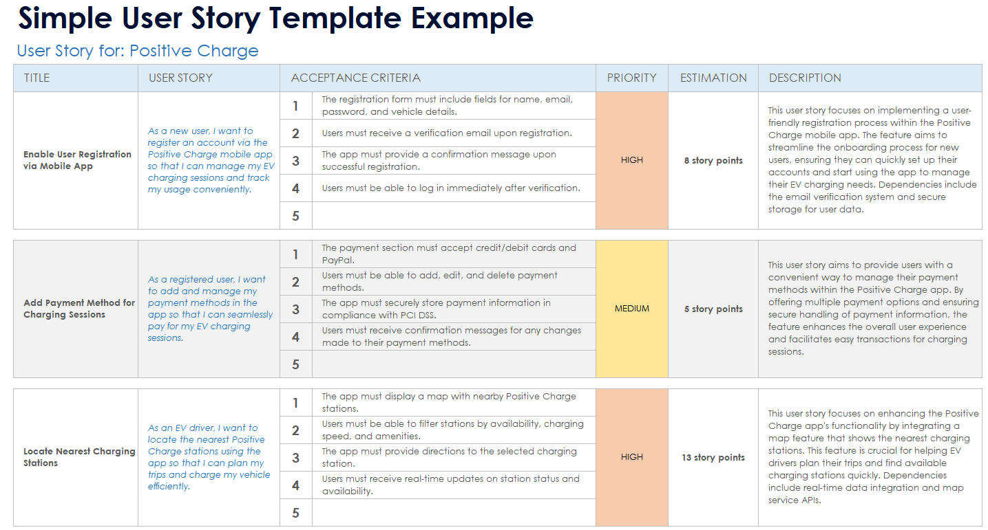
- UAT: user acceptance testing is done by a customer or the user
- Acceptance criteria are the set of minimum requirements to have a confirmation if that solution works
- Evaluation criteria woks best when there are multiple options or solutions and we will use weightage for the evaluation and rank it base on it's value
So ang acceptance criteria ay nangyayari before ang software development at ang UAT namana ay pagtapos ng development

- 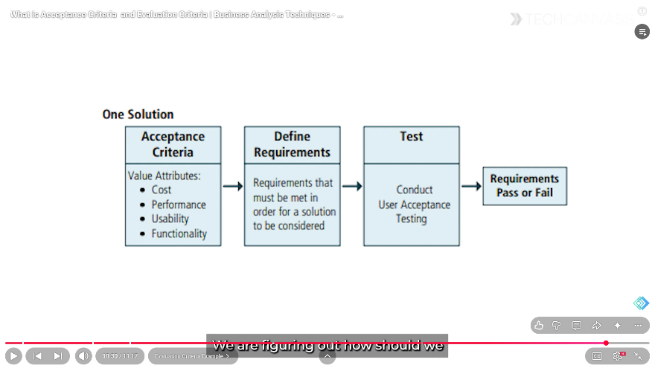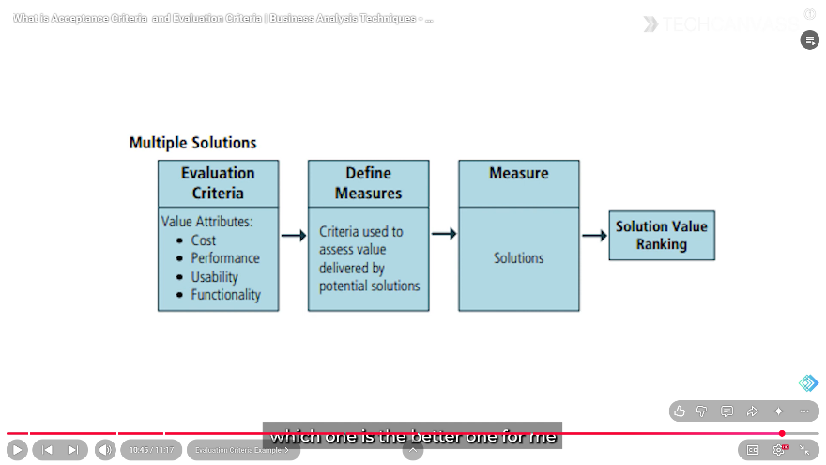

RADD Requirements Analysis and Design Definition
There are two terms describe in here “Analysis” and “Design” but we also have these three terms:
Needs: What does a business want? To address the problem, opportunity, risk or issue. A high level definition of what a business want
Requirements: A useful presentation of needs. Detailing the needs by collaborating with stakeholders. (requirements are from the needs).
Design: A useful representation of requirements from the solution perspective. Multiple design options are available. (prototype). At this stage, the solution will not yet be implemented, just a representation.

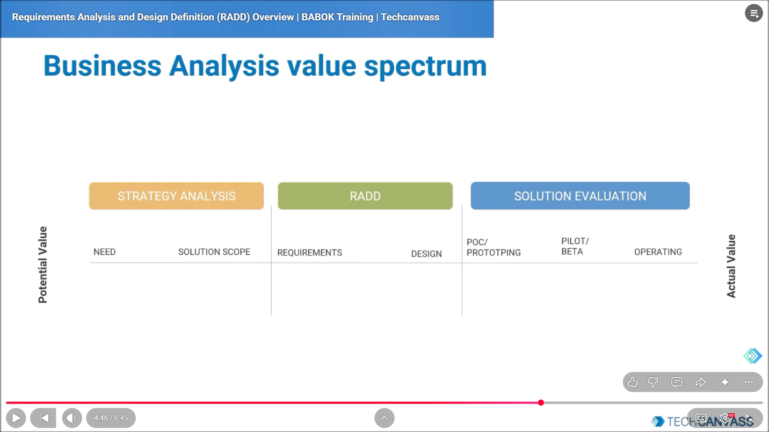
- STRATEGY ANALYSIS (Need → Solution Scope): dito nagsisimula ang lahat. "Need" — ito yung tinutukoy natin dati sa bank example ("gustong tumaas ng 10% kada quarter"). "Solution Scope" — pagkatapos malaman ang need, dito mo na binabalangkas kung gaano kalaki/kaunti ang sasakupin ng solusyon (tandaan, scope creep/in-scope/out-of-scope na natutunan mo sa BRD).
- RADD (Requirements → Design): 'to yung buong video na pinapanood mo ngayon. Dito na papasok ang "average balance and net worth" na requirement, at ang design ng screen/report na nakita natin kanina.
- SOLUTION EVALUATION (POC/Prototyping → Pilot/Beta → Operating): pagkatapos magawa ang design, susubukan muna ito sa maliit na saklaw (POC = proof of concept, o Prototype — mabilis na "sample" lang para makita kung gagana ang ideya), tapos Pilot/Beta (subukan sa mas malaking grupo, pero hindi pa buong kompanya — narito papasok ang UAT natin dati), at panghuli, Operating — buong gumagana na, ginagamit na araw-araw.

EXCEL FORMULA
- May mga instances na dapat drag down after isulat ang formula kasi ito yung standard sa workline dahil hindi lahat ng excel ay may dynamic array feature.
- Sa count diba nag purpose nito is magbilang pero yung count formula na to hindi siya tumatanggap ng text, dapat number lang so kung iuutos sayon a bilangin yung employees hindi ka sa first name o last name mag babase ng count Kundi either sa gender or sa id number.
- CHECKSUM: hindi to formula, ginagawa to to verify yung bago ka gumawa ng kahit anong complex na analysis o dashboard, kailangan mo munang i-verify kung buo at walang kulang sa na-export mong data.
- PRIORITY:
SUMIF
COUNTIF
IF
SUMIFS
COUNTIFS
IFS
- 2ND PRIORITY
SUM
COUNT
CONCATENATE
TEXT (DATE TO TEXT)
- NOT REALLY
LEN
TRIM
LEFT
RIGHT

- Sa date to text kapag month and year lang ang hinahanap pwedeng either mm/yyyy ang lalabas jan “01/2001” pero kapag mmm/yyyy lalabas ay “Jan/2001” pero pwede rin gamitin either / or – tas kapag mmmm naman buong name ng buwan

PROCESS FLOW DIAFRAM

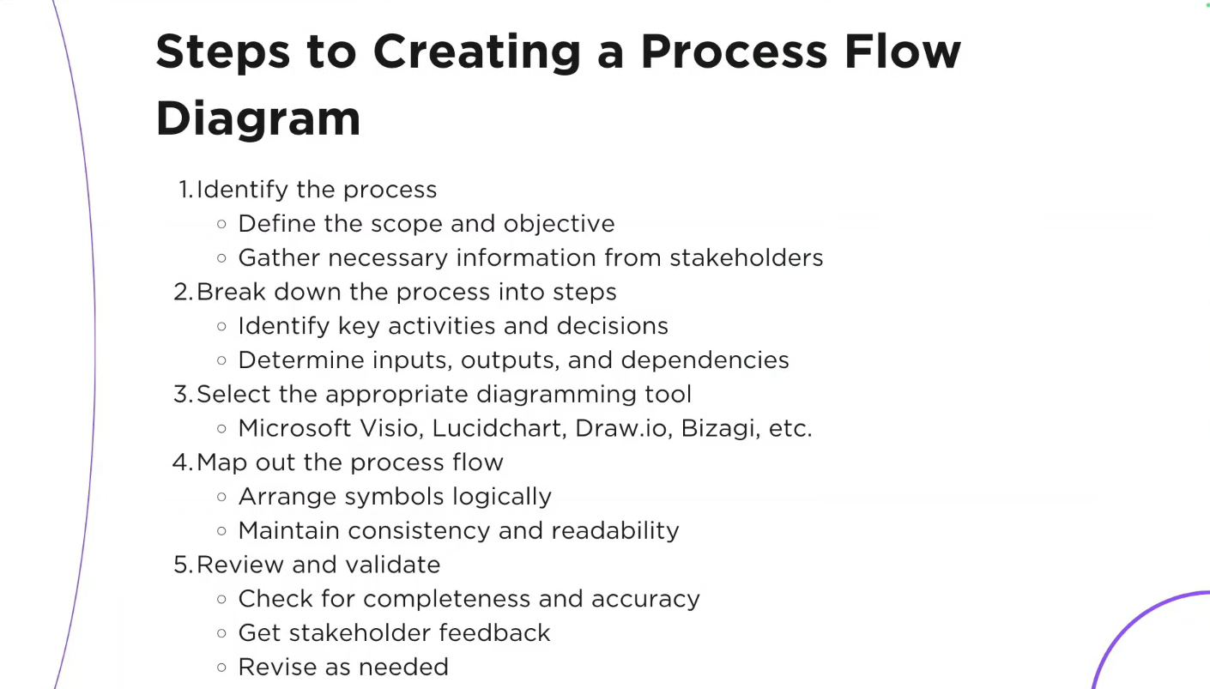
So in step 4 you can do a scratch from the paper of what could the process will look like before jumping out to the tool itself.

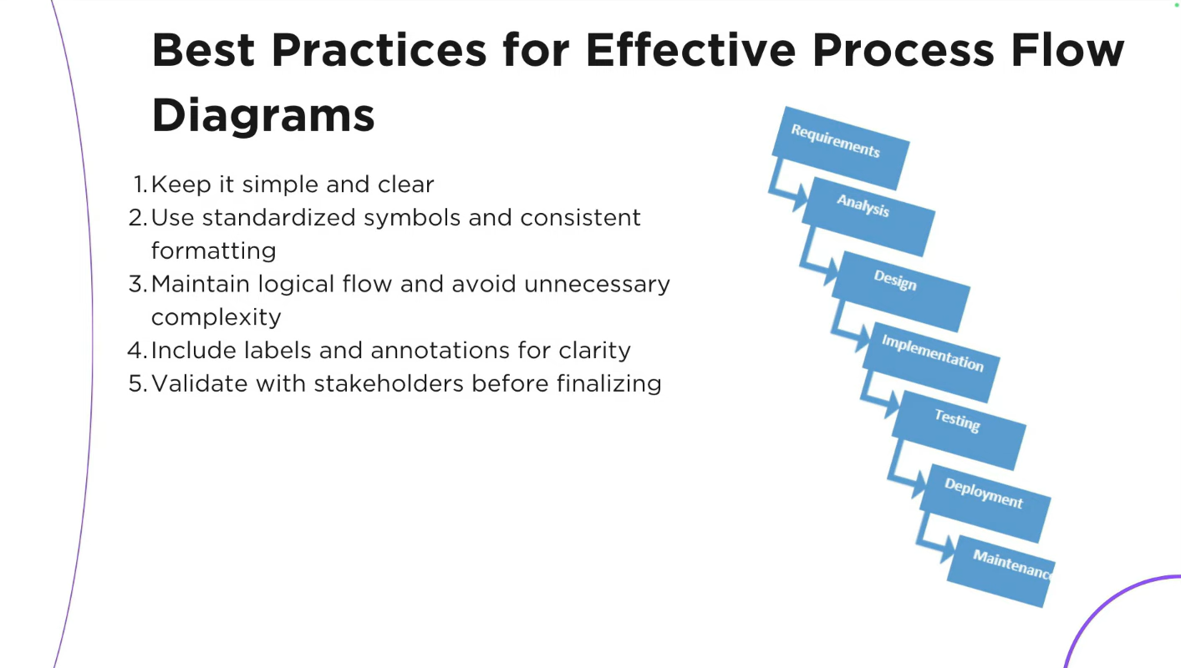
Keep it simple because not everyone is living in a business analyst world. So if you presented a complicated chart or process it defeats the purpose. So even if you wanted to be very detailed make it pretty. Just make it simple that everyone can understand with being confused due to over complication.

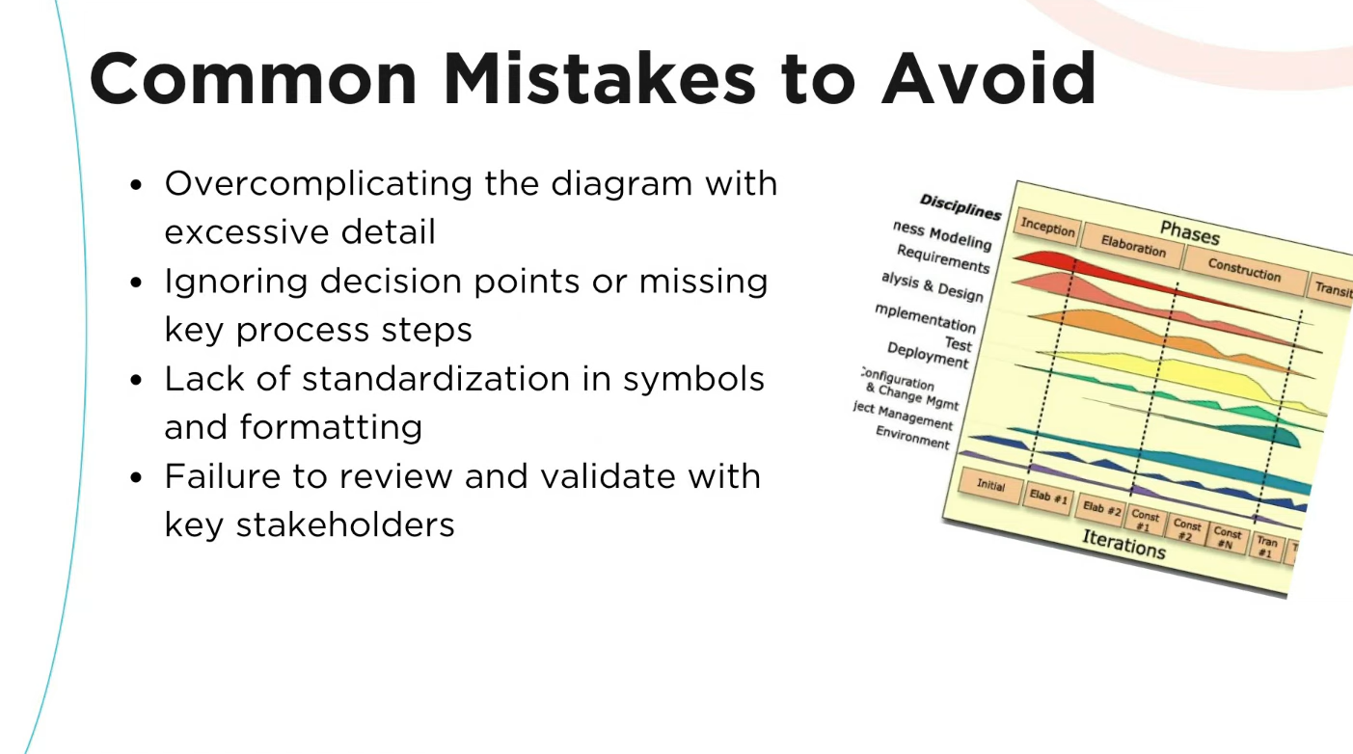
PROCESS FLOW IS USED IN:
REQUIREMENTS ELICITATION
STAKEHOLDER VALIDATION
GAP ANALYSIS
AS-IS VS TO-BE MODELING

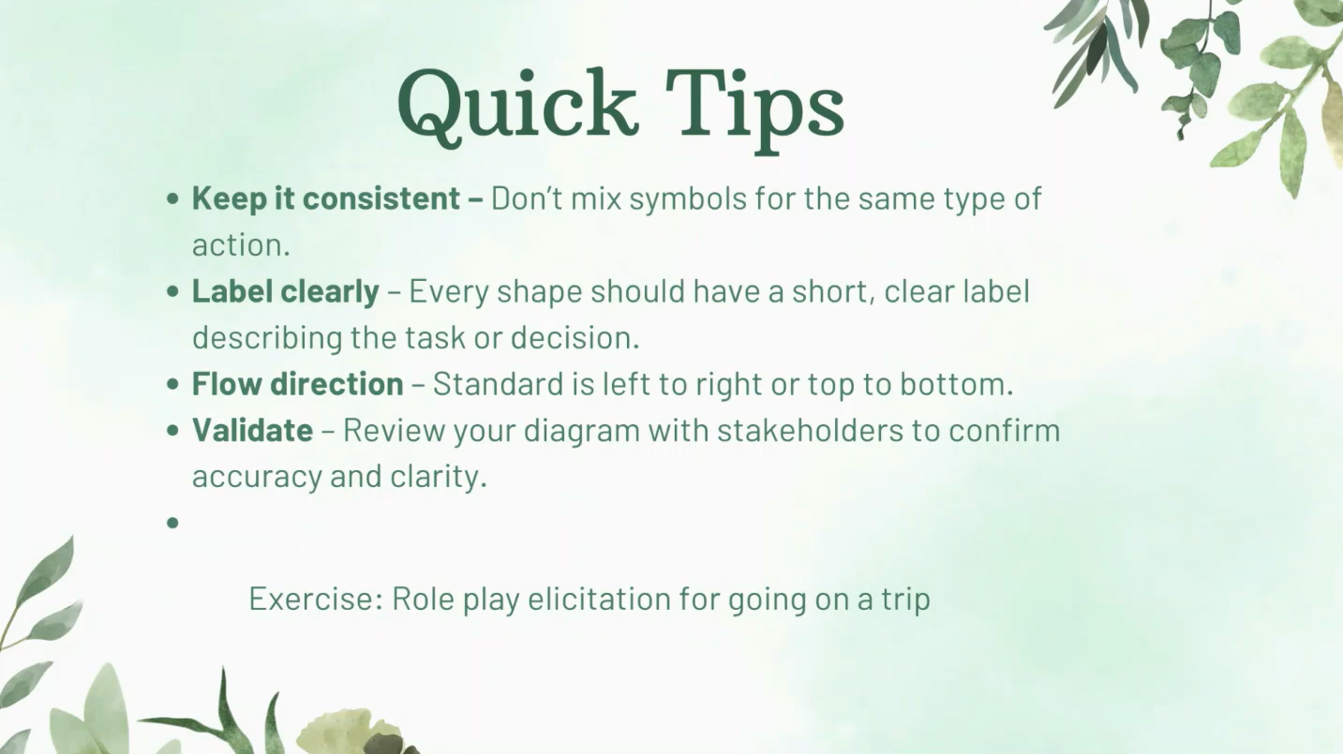

EXCEL CONDITIONAL FORMATTING
In using conditional formatting, you will see scales, different color gradient, so in excel it automatically computes for the maximum and minimum value and gets the 50th percentile.

EXCEL CREATING MAPS
- Go to the source sheet (the one who has all the data) click any cells. On insert tab click pivot table.
- Select the columns you need
- Click on the table created, and click on design and click on grand totals and subtotals remove or turn off those
- After that right click on the country if it contains your table and click on field setting. Click on layout and print and select show item labels in tabular form and tick the box for repeat item labels
- Now, copy the table and when pasting choose special pasting.

MYSQL DATA CLEANING PROJECT
-- DATA CLEANING

SELECT *
FROM layoffs;

-- STEPS
-- 1. Remove Duplicates
-- 2. Standardize the Data
-- 3. Null Values or Blank Values
-- 4. Remove any Columns

-- STAGING. pag copy ng original table para makapag edit
CREATE TABLE layoffs_staging
LIKE layoffs;

INSERT INTO layoffs_staging
SELECT *
FROM layoffs;

SELECT *
FROM layoffs_staging;

-- 1. Remove Duplicates
WITH duplicate_cte AS
(
SELECT *,
ROW_NUMBER() OVER (PARTITION BY company, location, industry, total_laid_off,
percentage_laid_off, `date`, stage, country, funds_raised_millions) AS row_num
FROM layoffs_staging
)
SELECT *
FROM duplicate_cte
where row_num > 1;

SELECT *
FROM layoffs_staging
WHERE company = 'Casper';

-- itong stage na to gumawa lang ulit ng another table para i-delete yung duplicate rows. hindi kasi pwedeng direct
-- na mag delete using CTE. so ganito yung magiging itsura ng query:
-- nakuha ko naman tong query na to right click mo lang yung table select mo yung "copy to clipboard" and then "create statement"
CREATE TABLE `layoffs_staging2` (
`company` text DEFAULT NULL,
`location` text DEFAULT NULL,
`industry` text DEFAULT NULL,
`total_laid_off` int(11) DEFAULT NULL,
`percentage_laid_off` text DEFAULT NULL,
`date` text DEFAULT NULL,
`stage` text DEFAULT NULL,
`country` text DEFAULT NULL,
`funds_raised_millions` int(11) DEFAULT NULL,
`row_num` INT
) ENGINE=InnoDB DEFAULT CHARSET=utf8mb4 COLLATE=utf8mb4_general_ci;

-- ito na yung sinasabi ko na approach para makapag delete
INSERT INTO layoffs_staging2
SELECT *,
ROW_NUMBER() OVER (PARTITION BY company, location, industry, total_laid_off,
percentage_laid_off, `date`, stage, country, funds_raised_millions) AS row_num
FROM layoffs_staging;

SELECT *
FROM layoffs_staging2
where row_num > 1;

DELETE
FROM layoffs_staging2
where row_num > 1;

-- 2. Standardize the Data
SELECT company, TRIM(company)
FROM layoffs_staging2;

UPDATE layoffs_staging2
SET company = TRIM(company);

SELECT *
FROM layoffs_staging2
WHERE industry LIKE 'Crypto%';

UPDATE layoffs_staging2
SET industry = 'Crypto'
WHERE industry LIKE 'Crypto%';

-- dalawang approach sa pagtanggal ng dot per mas safe yung trailing kasi what if may value na United states of AMerica
UPDATE layoffs_staging2
SET country = 'United States'
WHERE country LIKE 'United States%';

UPDATE layoffs_staging2
SET country = TRIM(TRAILING '.' FROM country)
WHERE country LIKE 'United States%';

SELECT `date`
FROM layoffs_staging2;

UPDATE layoffs_staging2
SET `date` = STR_TO_DATE(`date`, '%m/%d/%Y');

ALTER TABLE layoffs_staging2
MODIFY column `date` DATE;

-- 3. Null and Blank Values
-- not a part of the stage. just trying

SELECT *
FROM layoffs_staging2
WHERE total_laid_off IS NULL
AND percentage_laid_off IS NULL;

-- not a part of the stage. just trying
SELECT *
FROM layoffs_staging2
WHERE industry IS NULL
or industry = ' ';

UPDATE layoffs_staging2
SET industry = null
where industry = '';

select t1.industry, t2.industry
from layoffs_staging2 t1
join layoffs_staging2 t2
on t1.company = t2.company
where t1.industry is null
and t2.industry is not null;

update layoffs_staging2 t1
join layoffs_staging2 t2
on t1.company = t2.company
SET t1.industry = t2.industry
where t1.industry is null
and t2.industry is not null;

select *
from layoffs_staging2
where company LIKE 'Bally%';

-- 4. Deleting Rows

SELECT *
FROM layoffs_staging2
WHERE total_laid_off IS NULL
AND percentage_laid_off IS NULL;

DELETE
FROM layoffs_staging2
WHERE total_laid_off IS NULL
AND percentage_laid_off IS NULL;

select *
from layoffs_staging2;

ALTER TABLE layoffs_staging2
DROP COLUMN row_num;

MYSQL SYNTAX
-- FIRST VIDEO (SELECT STATEMENT)
SELECT *
FROM parks_and_recreation.employee_demographics;

-- YOU CAN ALSO SHOW JUST ONE COLUMN FROM EXAMPLE FIRST NAME
SELECT first_name
FROM parks_and_recreation.employee_demographics;

-- YOU CAN ALSO SHOW MULTIPLE COLUMN USING COMMA (,)
SELECT first_name,
last_name,
birth_date
FROM parks_and_recreation.employee_demographics;

-- YOU CAN ALSO HAVE CALCULTIONS IN MYSQL AND IT WILL CREATE A NEW COLUMN FOR IT. IT FOLLOWS PEMDAS
SELECT first_name,
last_name,
birth_date,
age + 10
FROM parks_and_recreation.employee_demographics;

-- DISTINCT STATEMENT
SELECT DISTINCT gender
FROM parks_and_recreation.employee_demographics;

-- SECOND VIDEO (WHERE CLAUSE) THIS IS FOR ROWS WHILE SELECT IS FOR COLUMNS
SELECT *
FROM parks_and_recreation.employee_salary
WHERE first_name = 'Leslie'
;

-- WE HAVE DIFFERENT COMPARISON OPERATORS
SELECT *
FROM parks_and_recreation.employee_salary
WHERE salary > 50000
;

-- ANOTHER EXAMPLE
SELECT *
FROM parks_and_recreation.employee_demographics
WHERE gender != 'Female'
;

-- ANOTHER EXAMPLE FOR DATE. FORMAT OF DATE IS YEAR MONTH AND DAY
SELECT *
FROM parks_and_recreation.employee_demographics
WHERE birth_date > '1985-01-01'
;

-- WE CAN USE LOGICAL OPERATORS: AND OR NOT
SELECT *
FROM parks_and_recreation.employee_demographics
WHERE birth_date > '1985-01-01'
AND gender = 'Male'
;

-- YOU CAN BE ALSO SO SPECIFIC
SELECT *
FROM parks_and_recreation.employee_demographics
WHERE (first_name = 'Leslie' AND age = 44) OR age > 55
;

-- LIKE STATEMENT WE HAVE TWO SYMBOLS FOR THIS. FIRST IS PERCENTAGE (%) IT MEANS ANYTHING WE CAN USE THIS BEFORE AND AFTER THE
-- VALUE FOR EXAMPLE JERRY SO IT'S EITHER 'JER%' OR '%ER' BUT WHEN WE USE UNDERSCORE (_) IT SPECIFIES HOW MANY LETTERS ARE
-- AFTER IT FOR EXAMPLE 'ANN' THEN 'A__' IT MEANS NO LESS AND NO MORE LETTERS
SELECT *
FROM parks_and_recreation.employee_demographics
WHERE first_name LIKE 'Les%'
;
-- YOU CAN ALSO COMBINE IT AND YOU CAN USE IT FOR DATE
SELECT *
FROM parks_and_recreation.employee_demographics
WHERE birth_date LIKE '1989%'
;

-- GROUP BY (max, min, count)
SELECT gender, AVG(age)
FROM employee_demographics
GROUP BY gender
;

-- ORDER BY (ASC AND DESC)
SELECT *
FROM employee_demographics
ORDER BY 2
;

-- HAVING AND WHERE
SELECT occupation, AVG(salary)
FROM employee_salary
WHERE occupation LIKE '%manager%'
GROUP BY occupation
HAVING AVG(salary) > 75000
;

-- LIMIT
SELECT *
FROM employee_demographics
ORDER BY age DESC
LIMIT 2, 1
;

-- ALIASING
SELECT gender, AVG(age) avg_age
FROM employee_demographics
GROUP BY gender
HAVING avg_age > 40;

-- INNER JOIN. LAHAT NG PAREHONG COLUMN IN ROWS IT WILL RETURN
SELECT dem.employee_id, age, occupation, salary
FROM employee_demographics dem
JOIN employee_salary sal
ON dem.employee_id = sal.employee_id
;

-- OUTER JOIN LEFT OUTER AND RIGHT OUTER. SA LEFT JOIN, LAHAT NG NASA LEFT NA TABLE PARANG SIYA YUNG PRIMARY KEY TAPOS LAHAT NG
-- KUNWARE EMPLOYEE_ID 1 TO 12 TAS WALA SIYANG 2 THEN HINDI LALABAS SA KABILANG TABLE YUNG 2 KASI DAPAT MATCH SILA DEPENDE SA
-- NASA LEFT NA TABLE. GANUN DIN SA RIGHT JOIN
SELECT *
FROM employee_demographics dem
RIGHT JOIN employee_salary sal
ON dem.employee_id = sal.employee_id
;

-- SELF JOIN
SELECT emp1.employee_id AS emp_santa,
emp1.first_name as first_name_santa,
emp1.last_name as last_name_santa,
emp2.employee_id AS emp_name,
emp2.first_name as first_name_emp,
emp2.last_name as last_name_emp
FROM employee_salary emp1
JOIN employee_salary emp2
ON emp1.employee_id + 1 = emp2.employee_id
;

-- JOINING MULTIPLE TABLE
SELECT *
FROM employee_demographics dem
JOIN employee_salary sal
ON dem.employee_id = sal.employee_id
JOIN parks_departments pd
ON sal.dept_id = pd.department_id
;

-- UNION. YOU CAN USE ALL OR DISTINCT
SELECT age, gender -- first_name, last_name
FROM employee_demographics
UNION
SELECT first_name, last_name
FROM employee_salary
;

-- union
SELECT first_name, last_name, 'Old Man' Label
FROM employee_demographics
WHERE age > 40 AND gender = 'Male'
UNION
SELECT first_name, last_name, 'Old Lady ' Label
FROM employee_demographics
WHERE age > 40 AND gender = 'Female'
UNION
SELECT first_name, last_name, 'Highly Paid Employee' Label
FROM employee_salary
WHERE salary > 70000
ORDER BY first_name, last_name
;

-- STRING FUNCTIONS
-- LENGTH
SELECT first_name, LENGTH(first_name)
FROM employee_demographics
ORDER BY 2;

-- UPPER AND LOWER
SELECT first_name, UPPER(first_name)
FROM employee_demographics;

SELECT first_name, LOWER(first_name)
FROM employee_demographics;

-- TRIM, LEFT AND RIGHT

SELECT TRIM(' REX ');
SELECT LTRIM(' REX ');
SELECT RTRIM(' REX ');

-- SUBSTRING
SELECT first_name,
SUBSTRING(birth_date,6,2) AS Birth_Month
FROM employee_demographics;

-- we can also do left and right
SELECT first_name, LEFT(first_name, 4)
FROM employee_demographics;

-- REPLACE
SELECT first_name, REPLACE(first_name, 'L', 'z')
FROM employee_demographics;

-- LOCATE
SELECT first_name, LOCATE ('L', 'Leslie')
FROM employee_demographics
LIMIT 1;

SELECT first_name, LOCATE ('An', first_name)
FROM employee_demographics;

-- CONCATINATION

SELECT first_name, last_name,
CONCAT(first_name,' ', last_name) AS FULL_NAME
FROM employee_demographics;

-- CASE STATEMENT
SELECT first_name,
last_name,
age,
CASE
WHEN age <= 30 THEN 'YOUNG'
WHEN age BETWEEN 31 AND 50 THEN 'ADULT'
ELSE 'UNKNOWN'
END AS IDENTIFICATION
FROM employee_demographics;

-- ANOTHER EXAMPLE
-- PAY INCREASE AND BONUS
-- < 50000 = 5%
-- > 50000 = 7%
-- FINANCE = 10% BONUS
SELECT first_name,
last_name,
salary,
CASE
WHEN salary < 50000 THEN salary + (salary * 0.05)
WHEN salary > 50000 THEN salary * 1.07
END AS RAISE,
CASE
WHEN dept_id = 6 THEN salary * .10
END AS Bonus
FROM employee_salary;

-- SUBQUERY

SELECT *
FROM employee_demographics
WHERE employee_id IN
(SELECT employee_id
FROM employee_salary
WHERE dept_id = 1)
;

SELECT first_name, salary,
(SELECT AVG(salary)
FROM employee_salary) AS AVG
FROM employee_salary;

-- FROM THE TOP!!!!!!!!!!!!!!!!!!!!!!!!!!!!!!!!!!!

-- SELECT STATEMENT
SELECT *
FROM parks_and_recreation.employee_demographics;

SELECT first_name,
last_name,
birth_date
FROM employee_demographics;

-- YOU CAN ALSO ADD INTEGER VALUE FROM AGE

SELECT first_name,
last_name,
birth_date,
age,
age + 10 as post_10
FROM employee_demographics;
#PEMDAS

# DISTINCT TO SHOW UNIQUE VALUES
SELECT DISTINCT gender
FROM employee_demographics;

JUST A RANDOM BA NOTES
Python, R, SAS, SPSS, Tableau, Power BI, Qlick View, SQL, EXCEL,

TERMINOLOGIES:
Agile & Scrum Methodologies

- Agile Methodology: An incremental and iterative approach to project management and software development that breaks work into stages to deliver value faster.
- Sprint: A short, time-boxed period in Agile where a specific task or shippable product increment is completed.
- Scrum Methodology: A lightweight process framework that sits under the broader Agile umbrella, utilizing small teams (8-10 members).
- Product Owner: The role responsible for prioritizing the product backlog, writing user stories, and maximizing the return on investment (ROI).
- Scrum Master: A servant-leader who ensures the team follows Scrum practices, removes obstacles, and encourages self-organization.
- Development Team: The individuals executing the work to build the product.
- Product Backlog: The master list of all features, requirements, and bug fixes needed to complete the entire project.
- Sprint Backlog: The specific subset of tasks pulled from the product backlog to be completed during the current sprint.
- Product Increment: The working prototype or version of the product delivered at the end of each sprint.
- Sprint Planning: A meeting where the team decides what tasks they will tackle in the upcoming sprint.
- Sprint Review: A meeting to demonstrate the work that was completed and shipped during the sprint.
- Sprint Retrospective: A reflection meeting to identify what went well and what processes need improvement for the next sprint.
- Daily Scrum: A daily 15-to-20-minute stand-up meeting to ensure the entire team is on the same page.
- Kanban: A scheduling system that visually manages workflow capacity (often using a board with "To Do," "In Progress," and "Done" columns).

Core Roles & General Concepts

- Business Analyst (BA): A professional who bridges the gap between IT and business teams by evaluating processes, determining requirements, and delivering data-driven solutions.
- Data Analyst: A professional focused on collecting, cleaning, processing, and performing statistical analysis on large datasets.
- Requirement: A targeted solution or specification needed to achieve a set business objective.
- Needs: A high-level representation of a business's ultimate goals and strategic direction.
- Project Deliverables: The measurable services, goods, or outcomes delivered to the end-user upon project completion.
- Benchmarking: Evaluating an organization's metrics, policies, or programs against standard criteria or competitors.

Analysis Techniques & Tools

- Cost-Benefit Analysis: An assessment of the anticipated financial benefits versus the costs to determine if a project is worth pursuing.
- Feasibility Study: A method used to gauge the potential success rate of a proposed business solution.
- Business Model Analysis: A technique to evaluate whether a business is financially, economically, and socially viable.
- MoSCoW Analysis: A prioritization technique that categorizes requirements into Must-have, Should-have, Could-have, and Would-have.
- SWOT Analysis: An evaluation framework covering a company’s Strengths, Weaknesses, Opportunities, and Threats.
- Gap Analysis: A comparison mapping out the differences between a current system's capabilities and the desired future state.
- BPMN (Business Process Model and Notation): A standard flowchart technique used to visually model the sequence of end-to-end business processes.
- Elicitation Techniques: The methods used to gather requirements from stakeholders (e.g., interviews, focus groups, document analysis, brainstorming).
- Pareto Analysis: A decision-making technique based on the 80/20 rule, assuming 80% of benefits/problems arise from 20% of the causes.

Project & Software Frameworks

Software Development Lifecycle (SDLC): The single software framework consisting of gathering, coding, operations, maintenance, and documentation.
- Project Lifecycle: A broader framework that can encompass multiple SDLCs, including idea generation, screening, testing, and analysis.
- Waterfall Model: A highly structured, sequential development methodology where testing only happens at the very end.
- V-Model: An SDLC model where execution happens sequentially in a V-shape, and the same person/team often reviews the stage before final testing.
- Fish Model: Similar to the V-Model but utilizes multiple, independent verification teams at every single stage (costly and time-consuming).

System Documentation & Mapping

- Basic Flow: The standard, expected operation of activities in a use-case scenario.
- Alternate Flow: The planned backup steps executed during a system failure.
- Exception Flow: The steps executed when errors occur that prevent the required goal from being achieved.
- BRD (Business Requirements Document): A formal, high-level document created by a BA that details exactly what the client requires from the software.
- SRS (System Requirement Specification): A highly technical document created by systems architects detailing the exact functional code requirements needed to build the software.

Risk Management

- Risk: A potential, predictable problem that *might* happen in the future and can be planned for proactively.
- Issue: A problem that is currently happening or actively failing; it can only be reacted to.
- Risk Mitigation: Creating a plan to minimize the damage or cost *after* a risk becomes reality.
- Risk Avoidance: Taking proactive steps to ensure the risk is entirely eliminated so it never happens in the first place.

CLEANING DATA IN EXCEL
File name: Data Cleaning Tutorial Excel
Disclaimer there are a lot of ways how to clean data in excel but this is how I learned it:
- Select any cell and go to the ribbon in “Data” and click “Remove Duplicates” under “Data Tools”
- I firstly, clean the name column, so insert a blank column after the name, and use this formula to make it uniform: “=PROPER(cell)” or “=UPPER(cell)”
- Now, if you encounter different values in a column for instance “Republican” and “Republicans” just choose all the cell and click on “filter” under “Data”. And try to go through those values that could be the same just like Republican and Republicans. It might just be a typo
- Another tip is to use the conditional formatting in that filtering, so you can just highlight the duplicate values, it is expected to highlight all the values right because it should be the same but if there is a cell that didn’t highlighted then it was a misspelled one just correct it. And there you found the error.
- Now, I fixed the vice column, you always need to have a blank column for every column you will fix. I just used trim in there because there are unnecessary spaces in those values, just cleaning it.
- When you’re working with salary or numerical values, you have to convert it into number because there are special signs like dollar or pound that could make it in chaos if it is in currency. So from currency to number, just convert it. No need for another column here. I just fixed the values of salary column. And remove the decimal places that has like .00
- If you are working with dates just convert it into “Short Date”

Full Project in Excel
- Create three sheets named “Working Sheet”, “Dashboard”, “Pivot Table”
- Always work on the Working Sheet. Select all then go to ribbon under “Data” and select “Filter” so this will apply to all columns in excel.
- Check the duplicates before doing anything else. So go to “Data” and click the “remove Duplicates” under “Data Tools”
- If you will encounter just letters in the dataset for example “M” that stands for Married, people wouldn’t understand what letter M is. You should specify it. Select the Column, Press Ctrl plus H, change the “Search” into “By Columns”.
- If you are working with the salary change the data type into Currency. Go to Home and under Number click the dropdown and select Currency. And always remove the 2 decimal places (.00).
- Now, for the Age column if there are a big range of age like from 28 to 68 years old it is advisable to have an age bracket. Create another column beside the Age column name it Age Bracket and use this formula: =IF(L2>=55, "Old", IF(L2>=31,"Middle Age", IF(L2<31, "Adolescent", "Invalid"))). This is a nested IF statement.
- Now, we are done cleaning the data. We are going to proceed in making the pivot table. Always use the working sheet as the scope or basis for the pivot table because those data there are now clean and ready for visualization.
- Tip: if you just want to see the average value of a column e.g. salary, under pivot table fields, just click the dropdown on the selected column and click the “Value Field Setting” and select average.
- Now insert a chart. Add Axis Title, Chart Title, and Data Table. Also change the Number Format from “Currency” to “Numbers” so go to “Value Field Settings” again and click the “Number Format” and select “Number”.
- If you also, wanted to refresh the data if you had changes, then just go to “Data” and click “Refresh Data”
- Now, we will create the Dashboard. Click the View and uncheck the gridlines so it looks good.
- Copy the Charts from the Pivot Table Sheets and paste it in the Dashboard Sheet. Design it like create a header then align the charts so it looks more presentable. Select the charts you want to align and click “Shape Format” and click “Align”.
- Now the exciting part. We will now add the slicer. Click any chart and select “PivotChart Analyze” and select “Insert Slicer”
- If you have now the slicer it is required to do “Report Connections” to all the pivot charts you made.

EXCEL POPULATING FROM PIVOT TABLE
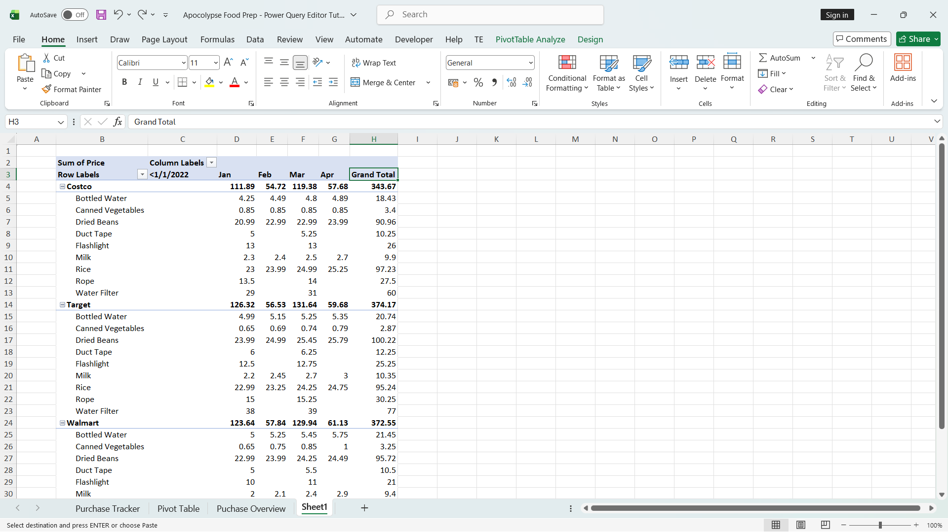
- Click any cell within the pivot table then go to the Design Tab.
- Click Report Layout then choose “Show in Tabular Form
- Now, still in Report Layout choose “Repeat All Item Labels”.
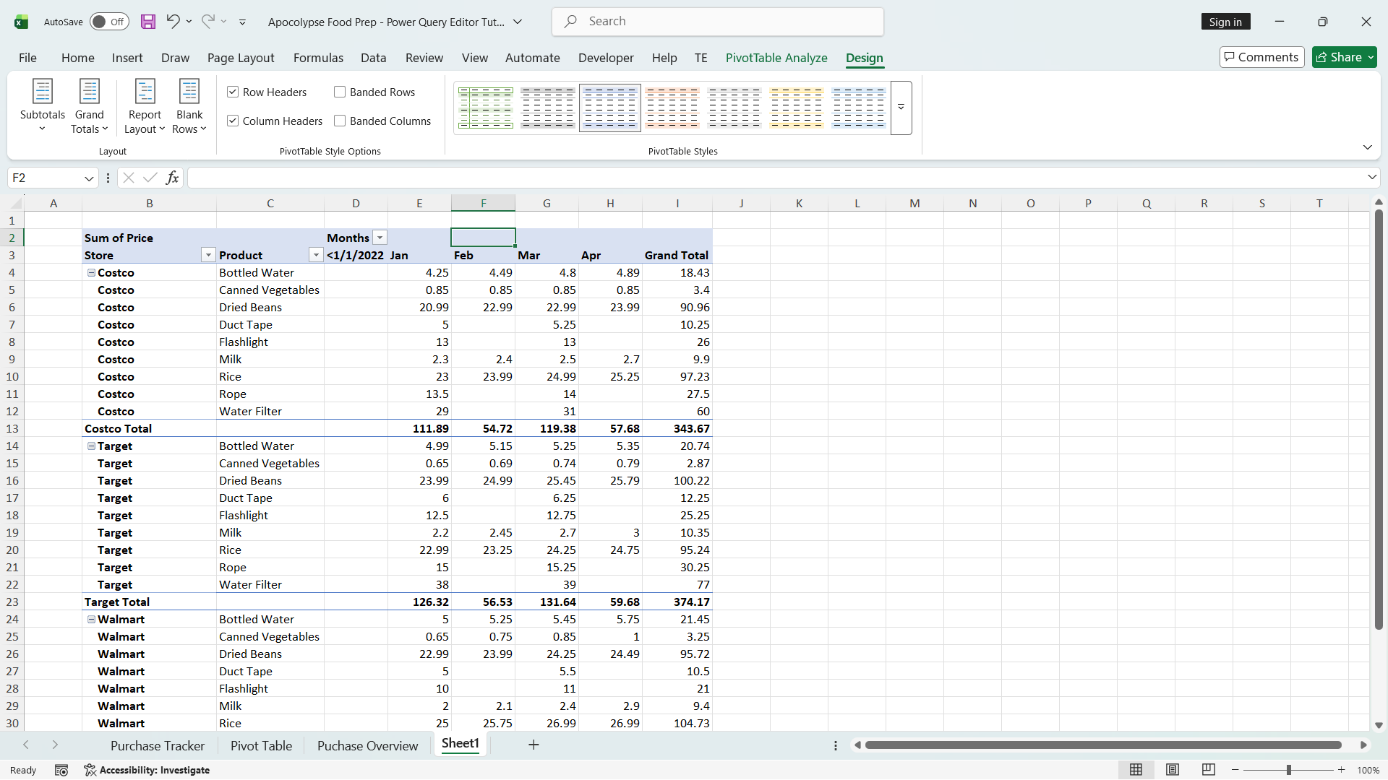

POWERBI POWERQUERY
- Remove the Top Rows first if the data has null or doesn’t contain any important values
- Make the first row as the header
- Now, if you are working with a currency set it to fixed decimal number
- Now if you wanted to remove a row like there is a grand total or subtotal as rows and there’s like a lot of null values on that row, there are two ways you can do to remove it, first is the dropdown the column and select remove empty. Second is still in the dropdown click “Text Filters” and click “Does not Contain”
- There is a tip alex told. It is to be careful of the data type specially for dates, because when you are working with two sheets and the first one is literally a date data type (1/1/2026) and the other sheet is (Jan,Feb,Mar) it will not look good and can destroy the visualization. So before importing it in pbi, make sure to double check it in excek.

DATACAMP
- Row can be also called as Record
- Columns can be also called as Field or Attribute
- Databases: A database is a system for managing data that allows us to store data reliably, retrieve information efficiently, and manipulate data systematically
Databases power web, mobile and other applications, as well as data analysis and reporting.
- Data Organization: Data in a database is organized into tables with rows and columns.
Rows represent individual entities or events.
Columns represent specific attributes or properties.
- SQL Basics
Structured Query Language (SQL) is the most widely used programming language for working with data in databases.
In its most common usage, you write SQL code to request data from databases, and they return the results you need.
SQL is much simpler than general programming languages because it's designed for one specific purpose: working with data.
- SQL requires precise syntax, and small mistakes can prevent queries from running.
Read error messages carefully, check spelling, use a good development environment, and leverage AI assistance.
The more you work with SQL, the fewer mistakes you'll make and the faster you'll spot and fix them.
- The original database remains unchanged when you run SELECT queries.
Query results are temporary snapshots of the data. To keep results for later use, you must save them to your computer or cloud storage.
- Database Server and Database Client

DATACAMP INTERMEDIATE
- Before writing aggregation function we have first to ask which column should we use for the aggregation function and next is what operation should we apply like min, max, or avg.
- 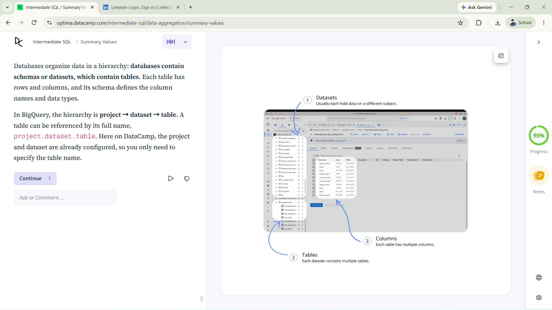
- Data aggregation is the operation of summarizing data by applying functions (like SUM, AVG, COUNT) to columns to produce single values.
- Data aggregation reveals insights and patterns that are difficult to recognize by examining raw data alone.
Summary Operations
- SUM(): Calculates the total of all values in a column
- AVG(): Calculates the average value in a column
- MIN(): Finds the minimum value in a column
- MAX(): Finds the maximum value in a column
- COUNT(): Counts the number of rows or values
- COUNT(DISTINCT column): Counts the number of unique values
Design Framework
- Thinking through your query before writing code is one of the most effective habits of successful data analysts.
- To effectively design a data aggregation operation, answer two key questions:
  - Which column do we wish to summarize? Select the column containing values relevant to your question.
  - Which summary operation do we wish to apply? Choose the appropriate operation based on the insight you need.

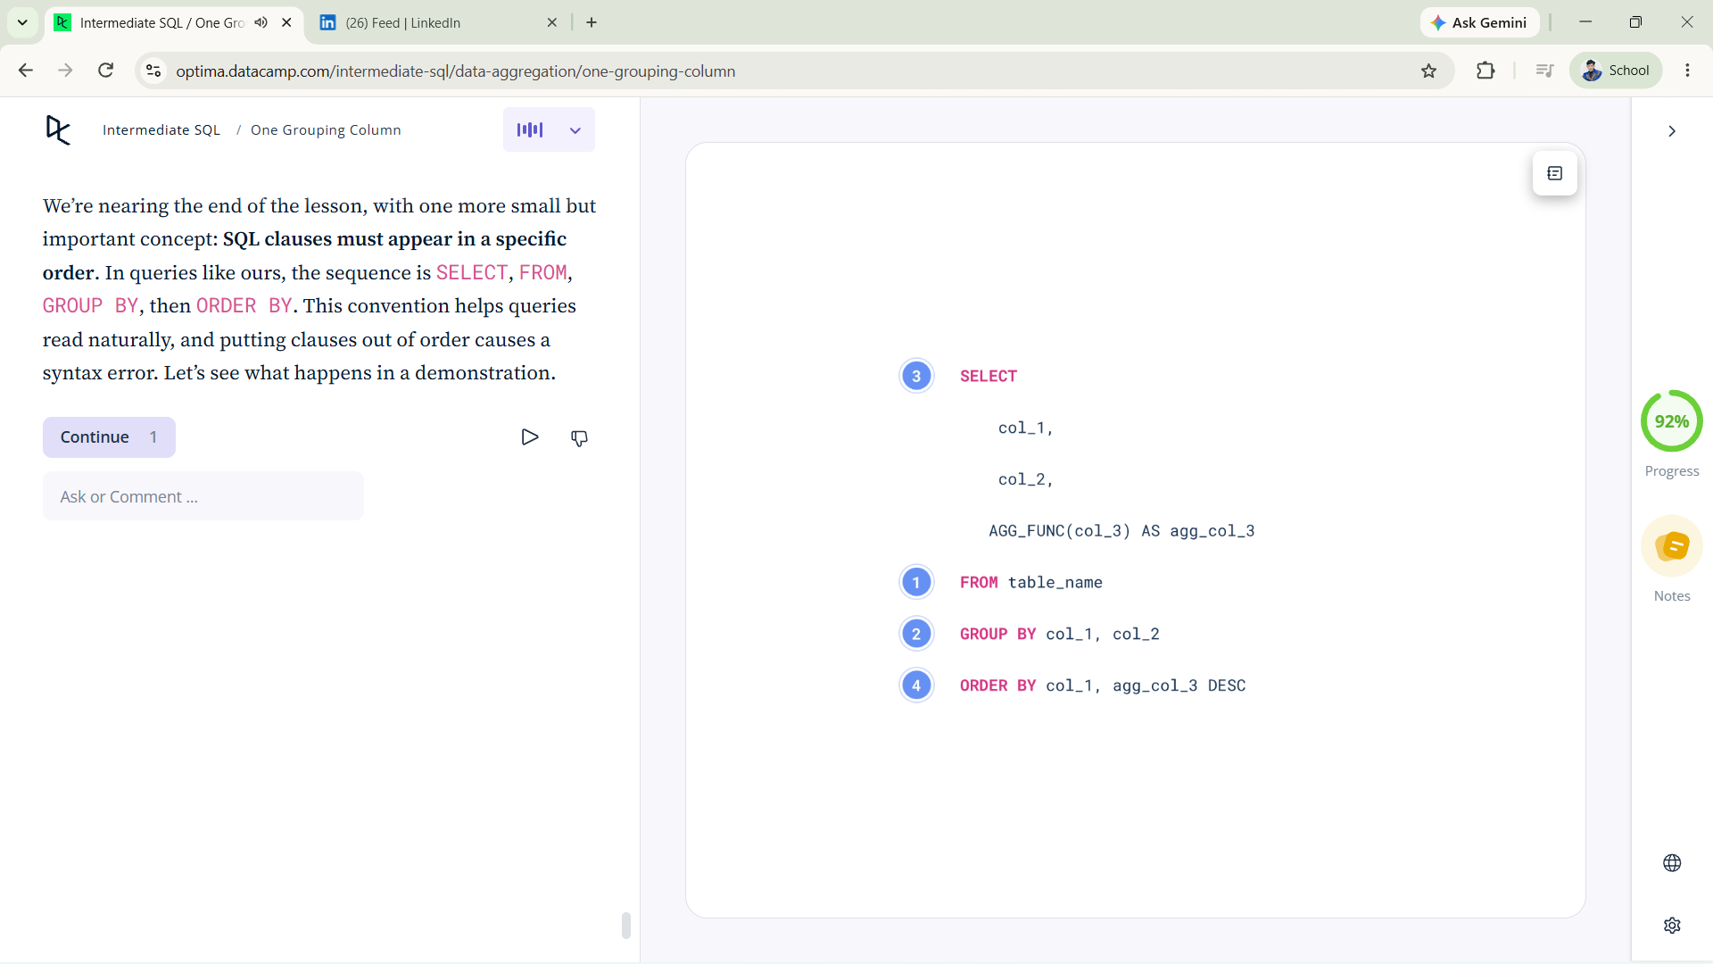
- Grouped aggregation is the overall process of calculating summary metrics separately for each group.
- Design Framework

To design an effective grouped aggregation, answer three questions:
- By which column do we group? The grouping column determines how rows are split into groups.
- Which column(s) do we summarize? The input columns on which metrics are calculated.
- Which summary operation(s) do we apply? Common operations include count, sum, mean, and unique count.
- Split-Apply-Combine
Grouped aggregation works through a three-step process:
- Split: Data is divided into groups based on unique values in the grouping column.
- Apply: Summary operations are performed on each group separately.
- Combine: Results from each group are assembled into a single summary table.
This happens behind the scenes when we use the GROUP BY clause.

- SQL Clause Order
- SQL requires clauses to be written in a specific order: SELECT → FROM → GROUP BY → ORDER BY.
- This is a syntax convention designed for readability.
- Placing clauses out of order produces a syntax error.
- Metric Reliability

- Summaries based on small groups are often unreliable. Exceptional values in small groups are frequently anomalies that disappear as group size increases.
- Always include the group size (typically a count) in summary tables to evaluate which summary values can be trusted.
- Trade-offs of Many Grouping Columns
You can group by as many columns as needed for the desired level of detail.
However, each additional grouping column increases the number of resulting groups.
Too many grouping columns can lead to:
- An overwhelming number of summary values that are challenging to interpret
- Smaller group sizes that produce less reliable summary statistics

- Data Transformation
- Data Transformation is a fundamental data manipulation operation that allows us to derive new columns from existing columns.
- With data transformation, the output table is a copy of the original input table with the new columns attached at the end. This is in contrast to data aggregation, which summarizes the data, providing a higher level, less granular view.

- Data Transformation in SQL
- We can create new columns in SQL by adding expressions in the SELECT statement.
SELECT *,
col_usd * 0.92 AS col_eur
FROM table_name;
- We can use any standard arithmetic operator to combine columns, as well as any SQL function.
- Use parentheses to group operations for clarity and to control operator precedence. When in doubt, add parentheses.
- Instead of SELECT * to select all columns, we can specify specific columns to include.

- Calculating Ratios
- Ratios measure relationships between different quantities and are calculated by dividing one column value by another.
- Division by zero is a common error in calculations.
- Use NULLIF to handle division by zero gracefully:
SELECT *,
col_a / NULLIF(col_b, 0) AS ratio
FROM table_name;
- Or use SAFE_DIVIDE to handle division by zero in BigQuery:
SELECT *,
SAFE_DIVIDE(col_a, col_b) AS ratio
FROM table_name;

